## Module A6 OS Concept Map.docx

**Objectives**

1. Research information about software for a specific operating system (OS) environment. You will be assigned one of the operating systems form the list of: Windows, Mac OS, Linux. You will also be provided with a list of topics to investigate.

2. Organize your rough research information into a list of topics, sub-topics, and facts. This process will involve identifying sub-topics, rearranging your rough research notes, and selecting (or highlighting) interesting facts.

3. Report a summary of your research in the form of a “concept map”. Use the PowerPoint template provided as a starting point. The concept map should only include the best and most interesting information from your organized research notes.

Your assigned operating system is:

· Windows

· Mac OS

· Linux

· iOS

· Android

A concept map can be created using the “Smart Ideas” application or PowerPoint or other applications.

**Level 1 – Rough Research**

Research information about the software for your assigned operating system (OS) environment.

· Guide your research according to the suggested topic list below

· Feel free to copy-and-paste as long as you keep track of your bibliographic references.

· Do not be too picky or concerned about formatting as you will organize this information later in step 2

· Select things that look interesting and don’t forget to include graphics images as well

· Upload your rough research notes to your repository when you are done.

The home screen, rendered by [SpringBoard](https://en.wikipedia.org/wiki/SpringBoard), displays [application](https://en.wikipedia.org/wiki/Application_software) icons and a dock at the bottom where users can pin their most frequently used apps. The home screen appears whenever the user unlocks the device or presses the physical "Home" button whilst in another app.[[57]](https://en.wikipedia.org/wiki/IOS#cite_note-57) Before iOS 4 on the iPhone 3GS (or later), the screen's background could be customized only through [jailbreaking](https://en.wikipedia.org/wiki/Jailbreaking_for_iOS), but can now be changed out-of-the-box. The screen has a status bar across the top to display data, such as time, battery level, and signal strength. The rest of the screen is devoted to the current application. When a passcode is set and a user switches on the device, the passcode must be entered at the Lock Screen before access to the Home screen is granted.

iOS 4 introduced folders, which can be created by dragging an application on top of another, and from then on, more items can be added to the folder using the same procedure. A title for the folder is automatically selected by the category of applications inside, but the name can also be edited by the user.[[71]](https://en.wikipedia.org/wiki/IOS#cite_note-Folders-71) When apps inside folders receive notification badges, the individual numbers of notifications are added up and the total number is displayed as a notification badge on the folder itself.[[71]](https://en.wikipedia.org/wiki/IOS#cite_note-Folders-71) Originally, folders on an iPhone could include up to 12 apps, while folders on iPad could include 20.[[72]](https://en.wikipedia.org/wiki/IOS#cite_note-72) With increasing display sizes on newer iPhone hardware, iOS 7 updated the folders with pages similar to the home screen layout, allowing for a significant expansion of folder functionality. Each page of a folder can contain up to nine apps, and there can be 15 pages in total, allowing for a total of 135 apps in a single folder.[[73]](https://en.wikipedia.org/wiki/IOS#cite_note-73) In iOS 9, Apple updated folder sizes for iPad hardware, allowing for 16 apps per page, still at 15 pages maximum, increasing the total to 240 apps.[[74]](https://en.wikipedia.org/wiki/IOS#cite_note-74)

Siri ([/ˈsɪəri/](https://en.wikipedia.org/wiki/Help:IPA/English)) is an [intelligent personal assistant](https://en.wikipedia.org/wiki/Intelligent_personal_assistant) integrated into iOS. The assistant uses voice queries and a [natural language user interface](https://en.wikipedia.org/wiki/Natural_language_user_interface) to answer questions, make recommendations, and perform actions by delegating requests to a set of Internet services. The software adapts to users' individual language usages, searches, and preferences, with continuing use. Returned results are individualized.

Siri supports a wide range of user commands, including performing phone actions, checking basic information, scheduling events and reminders, handling device settings, searching the Internet, navigating areas, finding information on entertainment, and is able to engage with iOS-integrated apps.[[106]](https://en.wikipedia.org/wiki/IOS#cite_note-106) With the release of [iOS 10](https://en.wikipedia.org/wiki/IOS_10) in 2016, Apple opened up limited third-party access to Siri, including third-party messaging apps, as well as payments, ride-sharing, and Internet calling apps.[[107]](https://en.wikipedia.org/wiki/IOS#cite_note-107)[[108]](https://en.wikipedia.org/wiki/IOS#cite_note-108) With the release of [iOS 11](https://en.wikipedia.org/wiki/IOS_11), Apple updated Siri's voices for more clear, human voices, it now supports follow-up questions and language translation, and additional third-party actions.[[109]](https://en.wikipedia.org/wiki/IOS#cite_note-109)[[110]](https://en.wikipedia.org/wiki/IOS#cite_note-110)

### **Keychain**

The iOS keychain is a [database](https://en.wikipedia.org/wiki/Database) of login information that can be shared across apps written by the same person or organization.[[168]](https://en.wikipedia.org/wiki/IOS#cite_note-:0-168) This service is often used for storing passwords for web applications.[[171]](https://en.wikipedia.org/wiki/IOS#cite_note-171)

### **Passcode**

iOS devices can have a passcode that is used to unlock the device, make changes to system settings, and encrypt the device's contents. Until recently, these were typically four numerical digits long. However, since unlocking the devices with a fingerprint by using Touch ID has become more widespread, six-digit passcodes are now the default on iOS with the option to switch back to four or use an alphanumeric passcode.[[168]](https://en.wikipedia.org/wiki/IOS#cite_note-:0-168)

### **Touch ID**

*Main article: [Touch ID](https://en.wikipedia.org/wiki/Touch_ID)*

Touch ID is a fingerprint scanner that is embedded in the home button and can be used to unlock the device, make purchases, and log into applications among other functions. When used, Touch ID only temporarily stores the fingerprint data in encrypted memory in the Secure Enclave, as described above. There is no way for the device's [main processor](https://en.wikipedia.org/wiki/Central_processing_unit) or any other part of the system to access the raw fingerprint data that is obtained from the Touch ID sensor.[[168]](https://en.wikipedia.org/wiki/IOS#cite_note-:0-168)

* [iPhone OS 1](https://en.wikipedia.org/wiki/IPhone_OS_1) – derived from "OS X" (At the time, "[macOS](https://en.wikipedia.org/wiki/MacOS)" was still known as "[Mac OS X](https://en.wikipedia.org/wiki/Mac_OS_X)" and not "[OS X](https://en.wikipedia.org/wiki/OS_X)" as it was known from 2012 to 2016.)
* [iPhone OS 2](https://en.wikipedia.org/wiki/IPhone_OS_2)
* [iPhone OS 3](https://en.wikipedia.org/wiki/IPhone_OS_3)
* [iOS 4](https://en.wikipedia.org/wiki/IOS_4) – continued from iPhone OS 3
* [iOS 5](https://en.wikipedia.org/wiki/IOS_5)
* [iOS 6](https://en.wikipedia.org/wiki/IOS_6)
* [iOS 7](https://en.wikipedia.org/wiki/IOS_7)
* [iOS 8](https://en.wikipedia.org/wiki/IOS_8)
* [iOS 9](https://en.wikipedia.org/wiki/IOS_9)
* [iOS 10](https://en.wikipedia.org/wiki/IOS_10)
* [iOS 11](https://en.wikipedia.org/wiki/IOS_11)
* [iOS 12](https://en.wikipedia.org/wiki/IOS_12)



[iTunes U](https://itunes.apple.com/ca/app/itunes-u/id490217893?mt=8)

[Education](https://itunes.apple.com/ca/app/itunes-u/id490217893?mt=8)

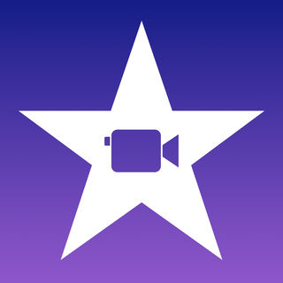

[iMovie](https://itunes.apple.com/ca/app/imovie/id377298193?mt=8)

[Photo & Video](https://itunes.apple.com/ca/app/imovie/id377298193?mt=8)

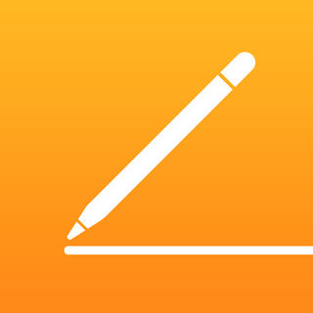

[Pages](https://itunes.apple.com/ca/app/pages/id361309726?mt=8)

[Productivity](https://itunes.apple.com/ca/app/pages/id361309726?mt=8)

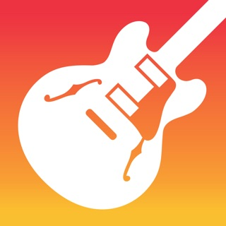

[GarageBand](https://itunes.apple.com/ca/app/garageband/id408709785?mt=8)

[Music](https://itunes.apple.com/ca/app/garageband/id408709785?mt=8)

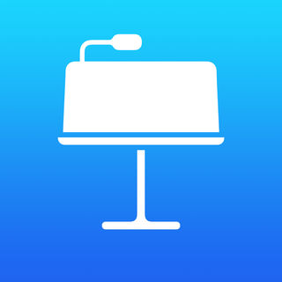

[Keynote](https://itunes.apple.com/ca/app/keynote/id361285480?mt=8)

[Productivity](https://itunes.apple.com/ca/app/keynote/id361285480?mt=8)

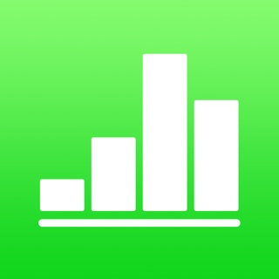

[Numbers](https://itunes.apple.com/ca/app/numbers/id361304891?mt=8)

[Productivity](https://itunes.apple.com/ca/app/numbers/id361304891?mt=8)

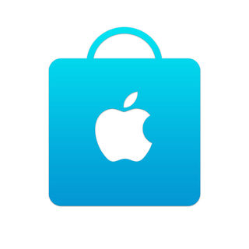

[Apple Store](https://itunes.apple.com/ca/app/apple-store/id375380948?mt=8)

[Shopping](https://itunes.apple.com/ca/app/apple-store/id375380948?mt=8)

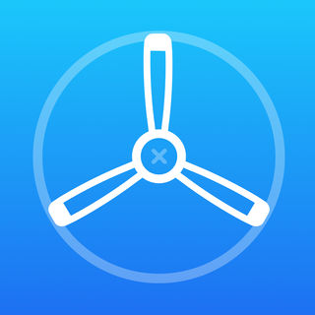

[TestFlight](https://itunes.apple.com/ca/app/testflight/id899247664?mt=8)

[Utilities](https://itunes.apple.com/ca/app/testflight/id899247664?mt=8)

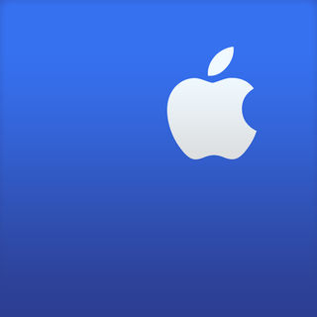

[Apple Support](https://itunes.apple.com/ca/app/apple-support/id1130498044?mt=8)

[Utilities](https://itunes.apple.com/ca/app/apple-support/id1130498044?mt=8)

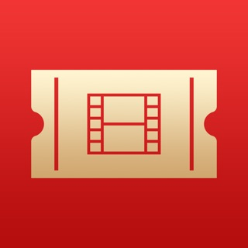

[iTunes Movie Trailers](https://itunes.apple.com/ca/app/itunes-movie-trailers/id471966214?mt=8)

[Entertainment](https://itunes.apple.com/ca/app/itunes-movie-trailers/id471966214?mt=8)

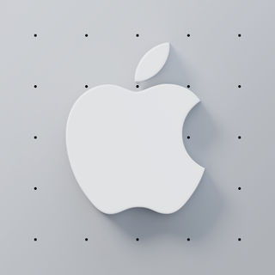

[WWDC](https://itunes.apple.com/ca/app/wwdc/id640199958?mt=8)

[Reference](https://itunes.apple.com/ca/app/wwdc/id640199958?mt=8)

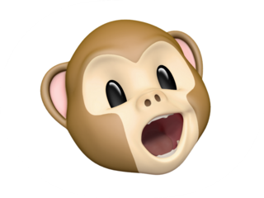

[Animoji](https://itunes.apple.com/ca/app/animoji/id1271507911?mt=8)

[Entertainment](https://itunes.apple.com/ca/app/animoji/id1271507911?mt=8)



[Smileys](https://itunes.apple.com/ca/app/smileys/id1127555487?mt=8)

[Stickers](https://itunes.apple.com/ca/app/smileys/id1127555487?mt=8)

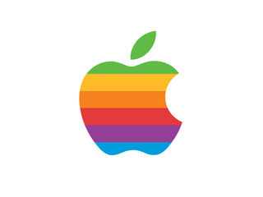

[Classic Mac](https://itunes.apple.com/ca/app/classic-mac/id1127542169?mt=8)

[Stickers](https://itunes.apple.com/ca/app/classic-mac/id1127542169?mt=8)

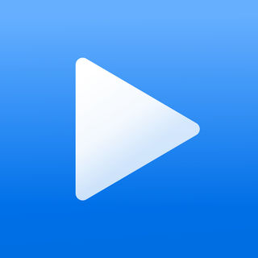

[iTunes Remote](https://itunes.apple.com/ca/app/itunes-remote/id284417350?mt=8)

[Entertainment](https://itunes.apple.com/ca/app/itunes-remote/id284417350?mt=8)



[Apple Books](https://itunes.apple.com/ca/app/apple-books/id364709193?mt=8)

[Books](https://itunes.apple.com/ca/app/apple-books/id364709193?mt=8)

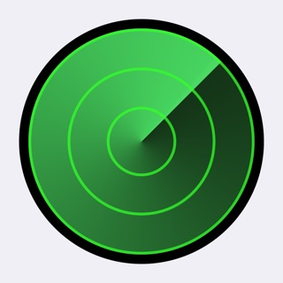

[Find My iPhone](https://itunes.apple.com/ca/app/find-my-iphone/id376101648?mt=8)

[Utilities](https://itunes.apple.com/ca/app/find-my-iphone/id376101648?mt=8)

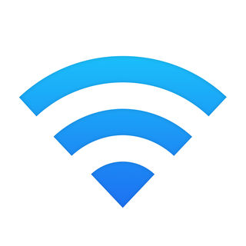

[AirPort Utility](https://itunes.apple.com/ca/app/airport-utility/id427276530?mt=8)

[Utilities](https://itunes.apple.com/ca/app/airport-utility/id427276530?mt=8)

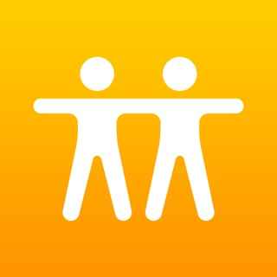

[Find My Friends](https://itunes.apple.com/ca/app/find-my-friends/id466122094?mt=8)

[Social Networking](https://itunes.apple.com/ca/app/find-my-friends/id466122094?mt=8)

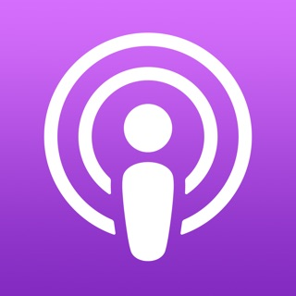

[Apple Podcasts](https://itunes.apple.com/ca/app/apple-podcasts/id525463029?mt=8)

[Entertainment](https://itunes.apple.com/ca/app/apple-podcasts/id525463029?mt=8)

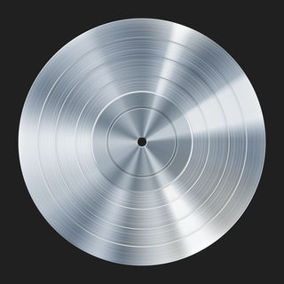

[Logic Remote](https://itunes.apple.com/ca/app/logic-remote/id638394624?mt=8)

[Music](https://itunes.apple.com/ca/app/logic-remote/id638394624?mt=8)

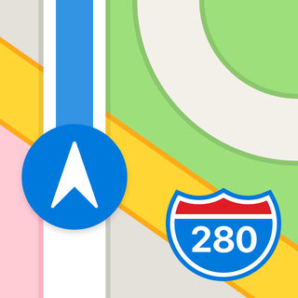

[Maps](https://itunes.apple.com/ca/app/maps/id915056765?mt=8)

[Navigation](https://itunes.apple.com/ca/app/maps/id915056765?mt=8)

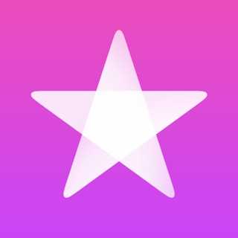

[iTunes Store](https://itunes.apple.com/ca/app/itunes-store/id915061235?mt=8)

[Entertainment](https://itunes.apple.com/ca/app/itunes-store/id915061235?mt=8)

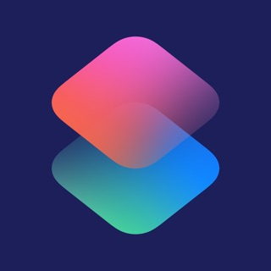

[Shortcuts](https://itunes.apple.com/ca/app/shortcuts/id915249334?mt=8)

[Productivity](https://itunes.apple.com/ca/app/shortcuts/id915249334?mt=8)

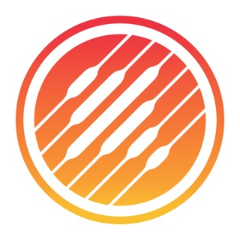

[Music Memos](https://itunes.apple.com/ca/app/music-memos/id1036437162?mt=8)

[Music](https://itunes.apple.com/ca/app/music-memos/id1036437162?mt=8)

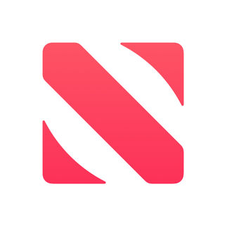

[Apple News](https://itunes.apple.com/ca/app/apple-news/id1066498020?mt=8)

[News](https://itunes.apple.com/ca/app/apple-news/id1066498020?mt=8)

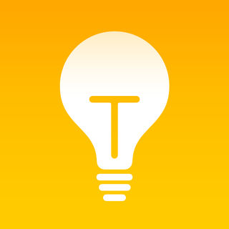

[Tips](https://itunes.apple.com/ca/app/tips/id1069509450?mt=8)

[Utilities](https://itunes.apple.com/ca/app/tips/id1069509450?mt=8)

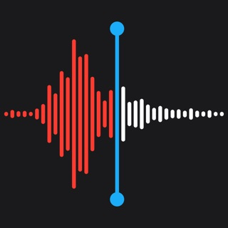

[Voice Memos](https://itunes.apple.com/ca/app/voice-memos/id1069512134?mt=8)

[Utilities](https://itunes.apple.com/ca/app/voice-memos/id1069512134?mt=8)



[Contacts](https://itunes.apple.com/ca/app/contacts/id1069512615?mt=8)

[Utilities](https://itunes.apple.com/ca/app/contacts/id1069512615?mt=8)

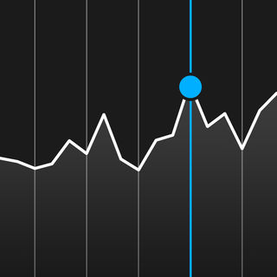

[Stocks](https://itunes.apple.com/ca/app/stocks/id1069512882?mt=8)

[Finance](https://itunes.apple.com/ca/app/stocks/id1069512882?mt=8)

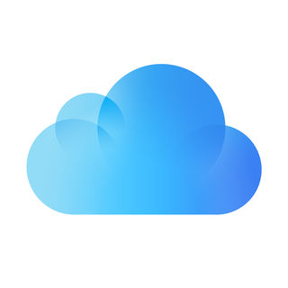

[iCloud Drive](https://itunes.apple.com/ca/app/icloud-drive/id1070072560?mt=8)

[Utilities](https://itunes.apple.com/ca/app/icloud-drive/id1070072560?mt=8)



[Apple TV Remote](https://itunes.apple.com/ca/app/apple-tv-remote/id1096834193?mt=8)

[Entertainment](https://itunes.apple.com/ca/app/apple-tv-remote/id1096834193?mt=8)



[Calendar](https://itunes.apple.com/ca/app/calendar/id1108185179?mt=8)

[Productivity](https://itunes.apple.com/ca/app/calendar/id1108185179?mt=8)



[Mail](https://itunes.apple.com/ca/app/mail/id1108187098?mt=8)

[Productivity](https://itunes.apple.com/ca/app/mail/id1108187098?mt=8)

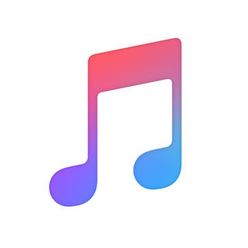

[Apple Music](https://itunes.apple.com/ca/app/apple-music/id1108187390?mt=8)

[Music](https://itunes.apple.com/ca/app/apple-music/id1108187390?mt=8)

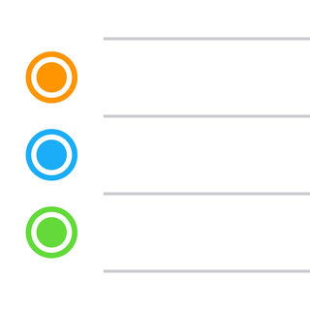

[Reminders](https://itunes.apple.com/ca/app/reminders/id1108187841?mt=8)

[Productivity](https://itunes.apple.com/ca/app/reminders/id1108187841?mt=8)



[Videos](https://itunes.apple.com/ca/app/videos/id1108188158?mt=8)

[Photo & Video](https://itunes.apple.com/ca/app/videos/id1108188158?mt=8)

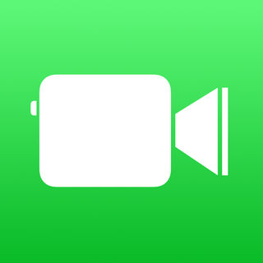

[FaceTime](https://itunes.apple.com/ca/app/facetime/id1110145091?mt=8)

[Social Networking](https://itunes.apple.com/ca/app/facetime/id1110145091?mt=8)

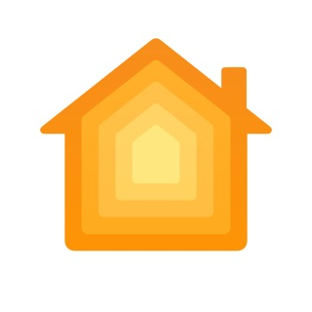

[Home](https://itunes.apple.com/ca/app/home/id1110145103?mt=8)

[Lifestyle](https://itunes.apple.com/ca/app/home/id1110145103?mt=8)

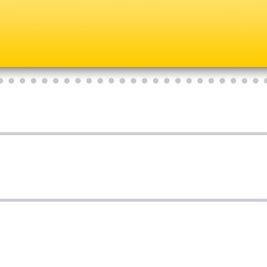

[Notes](https://itunes.apple.com/ca/app/notes/id1110145109?mt=8)

[Productivity](https://itunes.apple.com/ca/app/notes/id1110145109?mt=8)



[Hearts](https://itunes.apple.com/ca/app/hearts/id1127542179?mt=8)

[Stickers](https://itunes.apple.com/ca/app/hearts/id1127542179?mt=8)



[Hands](https://itunes.apple.com/ca/app/hands/id1127554252?mt=8)

[Stickers](https://itunes.apple.com/ca/app/hands/id1127554252?mt=8)



[Apple TV](https://itunes.apple.com/ca/app/apple-tv/id1174078549?mt=8)

[Entertainment](https://itunes.apple.com/ca/app/apple-tv/id1174078549?mt=8)

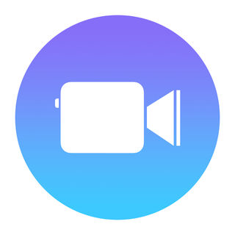

[Clips](https://itunes.apple.com/ca/app/clips/id1212699939?mt=8)

[Photo & Video](https://itunes.apple.com/ca/app/clips/id1212699939?mt=8)

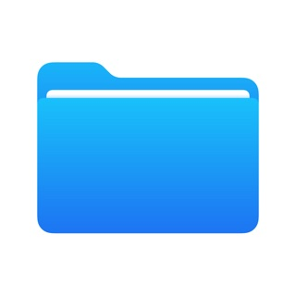

[Files](https://itunes.apple.com/ca/app/files/id1232058109?mt=8)

[Utilities](https://itunes.apple.com/ca/app/files/id1232058109?mt=8)

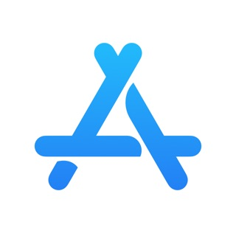

[App Store Connect](https://itunes.apple.com/ca/app/app-store-connect/id1234793120?mt=8)

[Utilities](https://itunes.apple.com/ca/app/app-store-connect/id1234793120?mt=8)

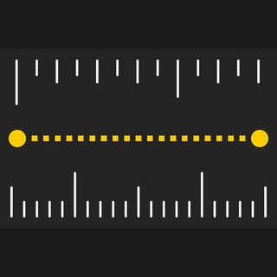

[Measure](https://itunes.apple.com/ca/app/measure/id1383426740?mt=8)

[Utilities](https://itunes.apple.com/ca/app/measure/id1383426740?mt=8)

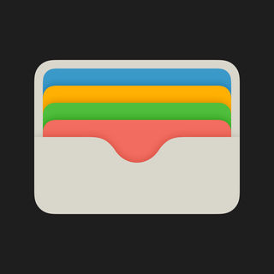

[Wallet](https://itunes.apple.com/ca/app/wallet/id1160481993?mt=8)

[Finance](https://itunes.apple.com/ca/app/wallet/id1160481993?mt=8)



[Beddit (for Model 3.5)](https://itunes.apple.com/ca/app/beddit-for-model-3-5/id1411596157?mt=8)

[Health & Fitness](https://itunes.apple.com/ca/app/beddit-for-model-3-5/id1411596157?mt=8)

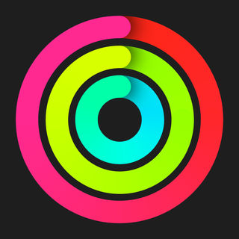

[Activity](https://itunes.apple.com/ca/app/activity/id1208224953?mt=8)

[Health & Fitness](https://itunes.apple.com/ca/app/activity/id1208224953?mt=8)



[Beats Pill⁺](https://itunes.apple.com/ca/app/beats-pill/id1005829608?mt=8)

[Utilities](https://itunes.apple.com/ca/app/beats-pill/id1005829608?mt=8)



[Compass](https://itunes.apple.com/ca/app/compass/id1067456176?mt=8)

[Navigation](https://itunes.apple.com/ca/app/compass/id1067456176?mt=8)

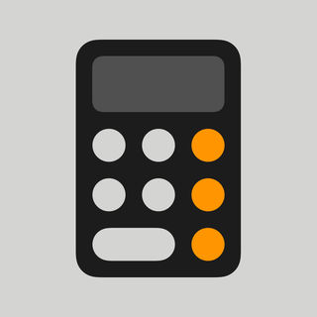

[Calculator](https://itunes.apple.com/ca/app/calculator/id1069511488?mt=8)

[Utilities](https://itunes.apple.com/ca/app/calculator/id1069511488?mt=8)

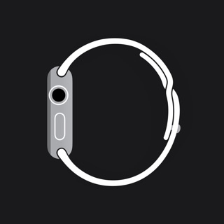

[Watch](https://itunes.apple.com/ca/app/watch/id1069511734?mt=8)

[Utilities](https://itunes.apple.com/ca/app/watch/id1069511734?mt=8)

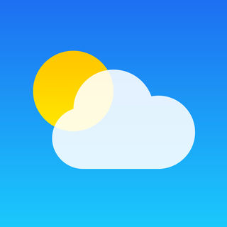

[Weather](https://itunes.apple.com/ca/app/weather/id1069513131?mt=8)

[Weather](https://itunes.apple.com/ca/app/weather/id1069513131?mt=8)

## **Apple - Apple Watch**



[Keynote](https://itunes.apple.com/ca/app/keynote/id361285480?mt=8)

[Productivity](https://itunes.apple.com/ca/app/keynote/id361285480?mt=8)



[Apple Store](https://itunes.apple.com/ca/app/apple-store/id375380948?mt=8)

[Shopping](https://itunes.apple.com/ca/app/apple-store/id375380948?mt=8)

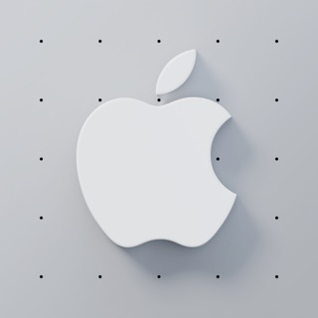

[WWDC](https://itunes.apple.com/ca/app/wwdc/id640199958?mt=8)

[Reference](https://itunes.apple.com/ca/app/wwdc/id640199958?mt=8)



[Wallet](https://itunes.apple.com/ca/app/wallet/id1160481993?mt=8)

[Finance](https://itunes.apple.com/ca/app/wallet/id1160481993?mt=8)



[Beddit (for Model 3.5)](https://itunes.apple.com/ca/app/beddit-for-model-3-5/id1411596157?mt=8)

[Health & Fitness](https://itunes.apple.com/ca/app/beddit-for-model-3-5/id1411596157?mt=8)



[Activity](https://itunes.apple.com/ca/app/activity/id1208224953?mt=8)

[Health & Fitness](https://itunes.apple.com/ca/app/activity/id1208224953?mt=8)



[Find My Friends](https://itunes.apple.com/ca/app/find-my-friends/id466122094?mt=8)

[Social Networking](https://itunes.apple.com/ca/app/find-my-friends/id466122094?mt=8)

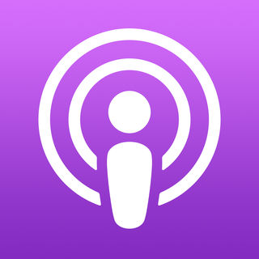

[Apple Podcasts](https://itunes.apple.com/ca/app/apple-podcasts/id525463029?mt=8)

[Entertainment](https://itunes.apple.com/ca/app/apple-podcasts/id525463029?mt=8)



[Maps](https://itunes.apple.com/ca/app/maps/id915056765?mt=8)

[Navigation](https://itunes.apple.com/ca/app/maps/id915056765?mt=8)



[Apple News](https://itunes.apple.com/ca/app/apple-news/id1066498020?mt=8)

[News](https://itunes.apple.com/ca/app/apple-news/id1066498020?mt=8)



[Stocks](https://itunes.apple.com/ca/app/stocks/id1069512882?mt=8)

[Finance](https://itunes.apple.com/ca/app/stocks/id1069512882?mt=8)



[Weather](https://itunes.apple.com/ca/app/weather/id1069513131?mt=8)

[Weather](https://itunes.apple.com/ca/app/weather/id1069513131?mt=8)



[Calendar](https://itunes.apple.com/ca/app/calendar/id1108185179?mt=8)

[Productivity](https://itunes.apple.com/ca/app/calendar/id1108185179?mt=8)



[Mail](https://itunes.apple.com/ca/app/mail/id1108187098?mt=8)

[Productivity](https://itunes.apple.com/ca/app/mail/id1108187098?mt=8)



[Apple Music](https://itunes.apple.com/ca/app/apple-music/id1108187390?mt=8)

[Music](https://itunes.apple.com/ca/app/apple-music/id1108187390?mt=8)



[Reminders](https://itunes.apple.com/ca/app/reminders/id1108187841?mt=8)

[Productivity](https://itunes.apple.com/ca/app/reminders/id1108187841?mt=8)



[Home](https://itunes.apple.com/ca/app/home/id1110145103?mt=8)

[Lifestyle](https://itunes.apple.com/ca/app/home/id1110145103?mt=8)

## **Apple TV**



[TestFlight](https://itunes.apple.com/ca/app/testflight/id899247664?mt=8)

[Utilities](https://itunes.apple.com/ca/app/testflight/id899247664?mt=8)

[](https://itunes.apple.com/ca/app/testflight/id899247664?mt=8)

[iTunes Movie Trailers](https://itunes.apple.com/ca/app/itunes-movie-trailers/id471966214?mt=8)

[Entertainment](https://itunes.apple.com/ca/app/itunes-movie-trailers/id471966214?mt=8)

[](https://itunes.apple.com/ca/app/itunes-movie-trailers/id471966214?mt=8)

[WWDC](https://itunes.apple.com/ca/app/wwdc/id640199958?mt=8)

[Reference](https://itunes.apple.com/ca/app/wwdc/id640199958?mt=8)

[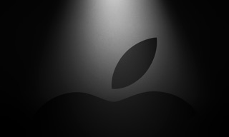](https://itunes.apple.com/ca/app/wwdc/id640199958?mt=8)

[Apple Events](https://itunes.apple.com/ca/app/apple-events/id1090599922?mt=8)

[News](https://itunes.apple.com/ca/app/apple-events/id1090599922?mt=8)

[](https://itunes.apple.com/ca/app/apple-events/id1090599922?mt=8)

### **Software updates**

*Main article: [iOS version history](https://en.wikipedia.org/wiki/IOS_version_history)*

*See also:* [*iPhone OS 1*](https://en.wikipedia.org/wiki/IPhone_OS_1)*,* [*iPhone OS 2*](https://en.wikipedia.org/wiki/IPhone_OS_2)*,* [*iPhone OS 3*](https://en.wikipedia.org/wiki/IPhone_OS_3)*,* [*iOS 4*](https://en.wikipedia.org/wiki/IOS_4)*,* [*iOS 5*](https://en.wikipedia.org/wiki/IOS_5)*,* [*iOS 6*](https://en.wikipedia.org/wiki/IOS_6)*,* [*iOS 7*](https://en.wikipedia.org/wiki/IOS_7)*,* [*iOS 8*](https://en.wikipedia.org/wiki/IOS_8)*,* [*iOS 9*](https://en.wikipedia.org/wiki/IOS_9)*,* [*iOS 10*](https://en.wikipedia.org/wiki/IOS_10)*,* [*iOS 11*](https://en.wikipedia.org/wiki/IOS_11)*, and [iOS 12](https://en.wikipedia.org/wiki/IOS_12)*

Platform usage as measured by the [App Store](https://en.wikipedia.org/wiki/App_Store_(iOS)) on February 24, 2019.[[46]](https://en.wikipedia.org/wiki/IOS#cite_note-IOS_Adoption_Rate-46)

[iOS 12](https://en.wikipedia.org/wiki/IOS_12) (80%)

[iOS 11](https://en.wikipedia.org/wiki/IOS_11) (12%)

[iOS 10](https://en.wikipedia.org/wiki/IOS_10) and earlier (8%)

Apple provides major updates to the iOS operating system annually via [iTunes](https://en.wikipedia.org/wiki/ITunes) and also, for iOS 5 and later, [over-the-air](https://en.wikipedia.org/wiki/Wireless).[[47]](https://en.wikipedia.org/wiki/IOS#cite_note-47) The latest version is [iOS 12](https://en.wikipedia.org/wiki/IOS_12), released on September 17, 2018.[[48]](https://en.wikipedia.org/wiki/IOS#cite_note-48) It is available for [iPhone 5S](https://en.wikipedia.org/wiki/IPhone_5S) and later, [iPad Air](https://en.wikipedia.org/wiki/IPad_Air) and later, [iPad Pro](https://en.wikipedia.org/wiki/IPad_Pro), [iPad Mini 2](https://en.wikipedia.org/wiki/IPad_Mini_2) and later, and sixth-generation [iPod Touch](https://en.wikipedia.org/wiki/IPod_Touch).[[49]](https://en.wikipedia.org/wiki/IOS#cite_note-49)

Originally, iPod Touch users had to pay for system software updates. This was due to accounting rules making the device not a "subscription device" like iPhone or Apple TV, and significant enhancements to the device required payments.[[50]](https://en.wikipedia.org/wiki/IOS#cite_note-50)[[51]](https://en.wikipedia.org/wiki/IOS#cite_note-51) The requirement to pay to upgrade caused iPod Touch owners to stay away from updates.[[52]](https://en.wikipedia.org/wiki/IOS#cite_note-52) However, in September 2009, a change in accounting rules won tentative approval, significantly affecting both Apple's earnings and stock price, and allowing iPod Touch updates to be delivered for free.[[53]](https://en.wikipedia.org/wiki/IOS#cite_note-53)[[54]](https://en.wikipedia.org/wiki/IOS#cite_note-54)

## Features

### **Home screen**

*Main article: [SpringBoard](https://en.wikipedia.org/wiki/SpringBoard)*

*[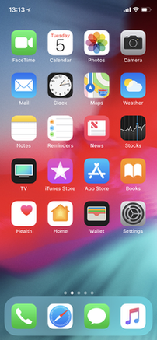](https://en.wikipedia.org/wiki/SpringBoard)*

[iOS 12](https://en.wikipedia.org/wiki/IOS_12) running on an iPhone X

The home screen, rendered by [SpringBoard](https://en.wikipedia.org/wiki/SpringBoard), displays [application](https://en.wikipedia.org/wiki/Application_software) icons and a dock at the bottom where users can pin their most frequently used apps. The home screen appears whenever the user unlocks the device or presses the physical "Home" button whilst in another app.[[55]](https://en.wikipedia.org/wiki/IOS#cite_note-55) Before iOS 4 on the iPhone 3GS (or later), the screen's background could be customized only through [jailbreaking](https://en.wikipedia.org/wiki/Jailbreaking_for_iOS), but can now be changed out-of-the-box. The screen has a status bar across the top to display data, such as time, battery level, and signal strength. The rest of the screen is devoted to the current application. When a passcode is set and a user switches on the device, the passcode must be entered at the Lock Screen before access to the Home screen is granted.[[56]](https://en.wikipedia.org/wiki/IOS#cite_note-56)

In iPhone OS 3, [Spotlight](https://en.wikipedia.org/wiki/Spotlight_(software)) was introduced, allowing users to search media, apps, emails, contacts, messages, reminders, calendar events, and similar content. In iOS 7 and later, Spotlight is accessed by pulling down anywhere on the home screen (except for the top and bottom edges that open Notification Center and Control Center).[[57]](https://en.wikipedia.org/wiki/IOS#cite_note-57)[[58]](https://en.wikipedia.org/wiki/IOS#cite_note-58) In iOS 9, there are two ways to access Spotlight. As with iOS 7 and 8, pulling down on any homescreen will show Spotlight. However, it can also be accessed as it was in iOS 3 – 6. This gives a Spotlight endowed with Siri suggestions, which include app suggestions, contact suggestions and news.[[59]](https://en.wikipedia.org/wiki/IOS#cite_note-59) In iOS 10, Spotlight is at the top of the now-dedicated "Today" panel.[[60]](https://en.wikipedia.org/wiki/IOS#cite_note-60)

Since iOS 3.2, users are able to set a background image for the Home screen. This feature is only available on third-generation devices—[iPhone 3GS](https://en.wikipedia.org/wiki/IPhone_3GS), third-generation [iPod touch](https://en.wikipedia.org/wiki/IPod_Touch) (iOS 4.0 or newer), all iPad models (since iOS 3.2)—or newer.

Researchers found that users organize icons on their homescreens based on usage-frequency and relatedness of the applications, as well as for reasons of usability and aesthetics.[[61]](https://en.wikipedia.org/wiki/IOS#cite_note-61)

#### **System font**

iOS originally used [Helvetica](https://en.wikipedia.org/wiki/Helvetica) as the system font. Apple switched to [Helvetica Neue](https://en.wikipedia.org/wiki/Helvetica_Neue) exclusively for the [iPhone 4](https://en.wikipedia.org/wiki/IPhone_4) and its [Retina Display](https://en.wikipedia.org/wiki/Retina_Display), and retained Helvetica as the system font for older iPhone devices on iOS 4.[[62]](https://en.wikipedia.org/wiki/IOS#cite_note-62) With iOS 7, Apple announced that they would change the system font to Helvetica Neue Light, a decision that sparked criticism for inappropriate usage of a light, thin typeface for low-resolution mobile screens. Apple eventually chose Helvetica Neue instead.[[63]](https://en.wikipedia.org/wiki/IOS#cite_note-63)[[64]](https://en.wikipedia.org/wiki/IOS#cite_note-64) The release of iOS 7 also introduced the ability to scale text or apply other forms of text accessibility changes through Settings.[[65]](https://en.wikipedia.org/wiki/IOS#cite_note-65)[[66]](https://en.wikipedia.org/wiki/IOS#cite_note-66) With iOS 9, Apple changed the font to [San Francisco](https://en.wikipedia.org/wiki/San_Francisco_(sans-serif_typeface)), an Apple-designed font aimed at maximum legibility and font consistency across its product lineup.[[67]](https://en.wikipedia.org/wiki/IOS#cite_note-67)[[68]](https://en.wikipedia.org/wiki/IOS#cite_note-68)

#### **Folders**

iOS 4 introduced folders, which can be created by dragging an application on top of another, and from then on, more items can be added to the folder using the same procedure. A title for the folder is automatically selected by the category of applications inside, but the name can also be edited by the user.[[69]](https://en.wikipedia.org/wiki/IOS#cite_note-Folders-69) When apps inside folders receive notification badges, the individual numbers of notifications are added up and the total number is displayed as a notification badge on the folder itself.[[69]](https://en.wikipedia.org/wiki/IOS#cite_note-Folders-69)Originally, folders on an iPhone could include up to 12 apps, while folders on iPad could include 20.[[70]](https://en.wikipedia.org/wiki/IOS#cite_note-70) With increasing display sizes on newer iPhone hardware, iOS 7 updated the folders with pages similar to the home screen layout, allowing for a significant expansion of folder functionality. Each page of a folder can contain up to nine apps, and there can be 15 pages in total, allowing for a total of 135 apps in a single folder.[[71]](https://en.wikipedia.org/wiki/IOS#cite_note-71) In iOS 9, Apple updated folder sizes for iPad hardware, allowing for 16 apps per page, still at 15 pages maximum, increasing the total to 240 apps.[[72]](https://en.wikipedia.org/wiki/IOS#cite_note-72)

#### **Notification Center**

*Main article: [Notification Center](https://en.wikipedia.org/wiki/Notification_Center)*

Before iOS 5, notifications were delivered in a [modal window](https://en.wikipedia.org/wiki/Modal_window) and couldn't be viewed after being dismissed. In iOS 5, Apple introduced [Notification Center](https://en.wikipedia.org/wiki/Notification_Center), which allows users to view a history of notifications. The user can tap a notification to open its corresponding app, or clear it.[[73]](https://en.wikipedia.org/wiki/IOS#cite_note-73) Notifications are now delivered in banners that appear briefly at the top of the screen. If a user taps a received notification, the application that sent the notification will be opened. Users can also choose to view notifications in modal alert windows by adjusting the application's notification settings. Introduced with iOS 8, widgets are now accessible through the Notification Center, defined by 3rd parties.

When an app sends a notification while closed, a red badge appears on its icon. This badge tells the user, at a glance, how many notifications that app has sent. Opening the app clears the badge.

### **Accessibility**

iOS offers various accessibility features to help users with vision and hearing disabilities. One major feature, [VoiceOver](https://en.wikipedia.org/wiki/VoiceOver), provides a voice reading information on the screen, including contextual buttons, icons, links and other [user interface](https://en.wikipedia.org/wiki/User_interface) elements, and allows the user to navigate the operating system through gestures. Any apps with default controls and developed with a UIKit [framework](https://en.wikipedia.org/wiki/Software_framework) gets VoiceOver functionality built in.[[74]](https://en.wikipedia.org/wiki/IOS#cite_note-74) One example includes holding up the iPhone to take a photo, with VoiceOver describing the photo scenery.[[75]](https://en.wikipedia.org/wiki/IOS#cite_note-75) As part of a "Made for iPhone" program, introduced with the release of [iOS 7](https://en.wikipedia.org/wiki/IOS_7) in 2013, Apple has developed technology to use [Bluetooth](https://en.wikipedia.org/wiki/Bluetooth) and a special technology protocol to let compatible third-party equipment connect with iPhones and iPads for streaming audio directly to a user's ears. Additional customization available for Made for iPhone products include battery tracking and adjustable sound settings for different environments.[[76]](https://en.wikipedia.org/wiki/IOS#cite_note-76)[[77]](https://en.wikipedia.org/wiki/IOS#cite_note-77)Apple made further efforts for accessibility for the release of [iOS 10](https://en.wikipedia.org/wiki/IOS_10) in 2016, adding a new pronunciation editor to VoiceOver, adding a Magnifier setting to enlarge objects through the device's camera, software [TTY](https://en.wikipedia.org/wiki/Telecommunications_device_for_the_deaf) support for deaf people to make phone calls from the iPhone, and giving tutorials and guidelines for third-party developers to incorporate proper accessibility functions into their apps.[[78]](https://en.wikipedia.org/wiki/IOS#cite_note-78)

In 2012, Liat Kornowski from [*The Atlantic*](https://en.wikipedia.org/wiki/The_Atlantic) wrote that "the iPhone has turned out to be one of the most revolutionary developments since the invention of [Braille](https://en.wikipedia.org/wiki/Braille)",[[79]](https://en.wikipedia.org/wiki/IOS#cite_note-79) and in 2016, Steven Aquino of [*TechCrunch*](https://en.wikipedia.org/wiki/TechCrunch) described Apple as "leading the way in assistive technology", with Sarah Herrlinger, Senior Manager for Global Accessibility Policy and Initiatives at Apple, stating that "We see accessibility as a basic human right. Building into the core of our products supports a vision of an inclusive world where opportunity and access to information are barrier-free, empowering individuals with disabilities to achieve their goals".[[80]](https://en.wikipedia.org/wiki/IOS#cite_note-80)

### **Multitasking**

[Multitasking](https://en.wikipedia.org/wiki/Computer_multitasking) for iOS was first released in June 2010 along with the release of [iOS 4](https://en.wikipedia.org/wiki/IOS_4).[[81]](https://en.wikipedia.org/wiki/IOS#cite_note-HuffPost1-81)[[82]](https://en.wikipedia.org/wiki/IOS#cite_note-PCMag1-82) Only certain devices—[iPhone 4](https://en.wikipedia.org/wiki/IPhone_4), [iPhone 3GS](https://en.wikipedia.org/wiki/IPhone_3GS), and [iPod Touch](https://en.wikipedia.org/wiki/IPod_Touch) 3rd generation—were able to multitask.[[83]](https://en.wikipedia.org/wiki/IOS#cite_note-Ars_Technica_iOS_4_review-83)The [iPad](https://en.wikipedia.org/wiki/IPad) did not get multitasking until iOS 4.2.1 in November.[[84]](https://en.wikipedia.org/wiki/IOS#cite_note-TheRegister1-84) Currently, multitasking is supported on iPhone 3GS+, iPod Touch 3rd generation+, and all iPad models.[[85]](https://en.wikipedia.org/wiki/IOS#cite_note-Apple1-85)

Implementation of multitasking in iOS has been criticized for its approach, which limits the work that applications in the background can perform to a limited function set and requires application developers to add explicit support for it.[[83]](https://en.wikipedia.org/wiki/IOS#cite_note-Ars_Technica_iOS_4_review-83)[[86]](https://en.wikipedia.org/wiki/IOS#cite_note-PCWorld2-86)

Before iOS 4, multitasking was limited to a selection of the applications Apple included on the device. Users could, however "jailbreak" their device in order to unofficially multitask.[[87]](https://en.wikipedia.org/wiki/IOS#cite_note-iOS_4_walkthrough-87) Starting with iOS 4, on third-generation and newer iOS devices, multitasking is supported through seven background [APIs](https://en.wikipedia.org/wiki/Application_programming_interface):[[88]](https://en.wikipedia.org/wiki/IOS#cite_note-88)

1. Background audio – application continues to run in the background as long as it is playing audio or video content[[89]](https://en.wikipedia.org/wiki/IOS#cite_note-Executing_Code_in_the_Background-89)
2. Voice over IP – application is suspended when a phone call is not in progress[[89]](https://en.wikipedia.org/wiki/IOS#cite_note-Executing_Code_in_the_Background-89)
3. Background location – application is notified of location changes[[89]](https://en.wikipedia.org/wiki/IOS#cite_note-Executing_Code_in_the_Background-89)
4. [Push notifications](https://en.wikipedia.org/wiki/Apple_Push_Notification_Service)
5. Local notifications – application schedules local notifications to be delivered at a predetermined time[[89]](https://en.wikipedia.org/wiki/IOS#cite_note-Executing_Code_in_the_Background-89)
6. Task completion – application asks the system for extra time to complete a given task[[89]](https://en.wikipedia.org/wiki/IOS#cite_note-Executing_Code_in_the_Background-89)
7. Fast app switching – application does not execute any code and may be removed from memory at any time[[89]](https://en.wikipedia.org/wiki/IOS#cite_note-Executing_Code_in_the_Background-89)

In iOS 5, three new background APIs were introduced:

1. Newsstand – application can download content in the background to be ready for the user[[89]](https://en.wikipedia.org/wiki/IOS#cite_note-Executing_Code_in_the_Background-89)
2. External Accessory – application communicates with an external accessory and shares data at regular intervals[[89]](https://en.wikipedia.org/wiki/IOS#cite_note-Executing_Code_in_the_Background-89)
3. Bluetooth Accessory – application communicates with a bluetooth accessory and shares data at regular intervals[[89]](https://en.wikipedia.org/wiki/IOS#cite_note-Executing_Code_in_the_Background-89)

In iOS 7, Apple introduced a new multitasking feature, providing all apps with the ability to perform background updates. This feature prefers to update the user's most frequently used apps and prefers to use WiFi networks over a cellular network, without markedly reducing the device's battery life.

#### **Switching applications**

In iOS 4.0 to iOS 6.x, double-clicking the home button activates the application switcher. A scrollable dock-like interface appears from the bottom, moving the contents of the screen up. Choosing an icon switches to an application. To the far left are icons which function as music controls, a rotation lock, and on iOS 4.2 and above, a volume controller.

With the introduction of iOS 7, double clicking the home button also activates the application switcher. However, unlike previous versions it displays screenshots of open applications on top of the icon and horizontal scrolling allows for browsing through previous apps, and it is possible to close applications by dragging them up, similar to how [WebOS](https://en.wikipedia.org/wiki/WebOS) handled multiple cards.[[90]](https://en.wikipedia.org/wiki/IOS#cite_note-Jon_Rubinstein:_OS_X_and_iOS_7_borrow_features_from_webOS-90)

With the introduction of iOS 9, the application switcher received a significant visual change; whilst still retaining the card metaphor introduced in iOS 7, the application icon is smaller, and appears above the screenshot (which is now larger, due to the removal of "Recent and Favorite Contacts"), and each application "card" overlaps the other, forming a [rolodex](https://en.wikipedia.org/wiki/Rolodex) effect as the user scrolls. Now, instead of the home screen appearing at the leftmost of the application switcher, it appears rightmost.[[91]](https://en.wikipedia.org/wiki/IOS#cite_note-91) In [iOS 11](https://en.wikipedia.org/wiki/IOS_11), the application switcher receives a major redesign. In the iPad, the [Control Center](https://en.wikipedia.org/wiki/Control_Center_(iOS)) and app switcher are combined. The app switcher in the iPad can also be accessed by swiping up from the bottom. In the iPhone, the app switcher cannot be accessed if there are no apps in the [RAM](https://en.wikipedia.org/wiki/RAM).

#### **Ending tasks**

In iOS 4.0 to iOS 6.x, briefly holding the icons in the application switcher makes them "jiggle" (similarly to the homescreen) and allows the user to *force* quit the applications by tapping the red minus circle that appears at the corner of the app's icon.[[92]](https://en.wikipedia.org/wiki/IOS#cite_note-iOS:_Force_an_app_to_close-92) Clearing applications from multitasking stayed the same from iOS 4.0 through 6.1.6, the last version of iOS 6.

As of iOS 7, the process has become faster and easier. In iOS 7, instead of holding the icons to close them, they are closed by simply swiping them upwards off the screen. Up to three apps can be cleared at a time compared to one in versions up to iOS 6.1.6.[[93]](https://en.wikipedia.org/wiki/IOS#cite_note-tuaw-93)

#### **Task completion**

Task completion allows apps to continue a certain task after the app has been suspended.[[94]](https://en.wikipedia.org/wiki/IOS#cite_note-MacWorld1-94)[[95]](https://en.wikipedia.org/wiki/IOS#cite_note-95) As of iOS 4.0, apps can request up to ten minutes to complete a task in the background.[[96]](https://en.wikipedia.org/wiki/IOS#cite_note-iLounge1-96) This doesn't extend to background up- and downloads though (e.g. if you start a download in one application, it won't finish if you switch away from the application).

### **Siri**

*Main article: [Siri](https://en.wikipedia.org/wiki/Siri)*

Siri ([/ˈsɪəri/](https://en.wikipedia.org/wiki/Help:IPA/English)) is an [intelligent personal assistant](https://en.wikipedia.org/wiki/Intelligent_personal_assistant) integrated into iOS. The assistant uses voice queries and a [natural language user interface](https://en.wikipedia.org/wiki/Natural_language_user_interface) to answer questions, make recommendations, and perform actions by delegating requests to a set of Internet services. The software adapts to users' individual language usages, searches, and preferences, with continuing use. Returned results are individualized.

Originally released as an app for iOS in February 2010,[[97]](https://en.wikipedia.org/wiki/IOS#cite_note-97) it was acquired by Apple two months later,[[98]](https://en.wikipedia.org/wiki/IOS#cite_note-98)[[99]](https://en.wikipedia.org/wiki/IOS#cite_note-99)[[100]](https://en.wikipedia.org/wiki/IOS#cite_note-100) and then integrated into [iPhone 4S](https://en.wikipedia.org/wiki/IPhone_4S) at its release in October 2011.[[101]](https://en.wikipedia.org/wiki/IOS#cite_note-101)[[102]](https://en.wikipedia.org/wiki/IOS#cite_note-102) At that time, the separate app was also removed from the iOS [App Store](https://en.wikipedia.org/wiki/App_Store_(iOS)).[[103]](https://en.wikipedia.org/wiki/IOS#cite_note-103)

Siri supports a wide range of user commands, including performing phone actions, checking basic information, scheduling events and reminders, handling device settings, searching the Internet, navigating areas, finding information on entertainment, and is able to engage with iOS-integrated apps.[[104]](https://en.wikipedia.org/wiki/IOS#cite_note-104) With the release of [iOS 10](https://en.wikipedia.org/wiki/IOS_10) in 2016, Apple opened up limited third-party access to Siri, including third-party messaging apps, as well as payments, ride-sharing, and Internet calling apps.[[105]](https://en.wikipedia.org/wiki/IOS#cite_note-105)[[106]](https://en.wikipedia.org/wiki/IOS#cite_note-106) With the release of [iOS 11](https://en.wikipedia.org/wiki/IOS_11), Apple updated Siri's voices for more clear, human voices, it now supports follow-up questions and language translation, and additional third-party actions.[[107]](https://en.wikipedia.org/wiki/IOS#cite_note-107)[[108]](https://en.wikipedia.org/wiki/IOS#cite_note-108)

### **Game Center**

*Main article: [Game Center](https://en.wikipedia.org/wiki/Game_Center)*

Game Center is an [online](https://en.wikipedia.org/wiki/Internet) [multiplayer](https://en.wikipedia.org/wiki/Multiplayer_video_game) "social gaming network"[[109]](https://en.wikipedia.org/wiki/IOS#cite_note-appleDEV-109) released by Apple.[[110]](https://en.wikipedia.org/wiki/IOS#cite_note-110) It allows users to "invite friends to play a game, start a multiplayer game through matchmaking, track their [achievements](https://en.wikipedia.org/wiki/Achievement_(video_gaming)), and compare their high scores on a [leaderboard](https://en.wikipedia.org/wiki/Ladder_tournament)." iOS 5 and above adds support for profile photos.[[109]](https://en.wikipedia.org/wiki/IOS#cite_note-appleDEV-109)

Game Center was announced during an iOS 4 preview event hosted by Apple on April 8, 2010. A preview was released to registered Apple developers in August.[[109]](https://en.wikipedia.org/wiki/IOS#cite_note-appleDEV-109) It was released on September 8, 2010 with iOS 4.1 on [iPhone 4](https://en.wikipedia.org/wiki/IPhone_4), iPhone 3GS, and iPod Touch 2nd generation through 4th generation.[[111]](https://en.wikipedia.org/wiki/IOS#cite_note-111) Game Center made its public debut on the iPad with iOS 4.2.1.[[112]](https://en.wikipedia.org/wiki/IOS#cite_note-iOS_4.2_for_iPad-112) There is no support for the [iPhone 3G](https://en.wikipedia.org/wiki/IPhone_3G), [original iPhone](https://en.wikipedia.org/wiki/IPhone_(original)) and the [first-generation iPod Touch](https://en.wikipedia.org/wiki/IPod_Touch) (the latter two devices did not have Game Center because they did not get iOS 4).[[113]](https://en.wikipedia.org/wiki/IOS#cite_note-Game_Center-113) However, Game Center is unofficially available on the iPhone 3G via a hack.[[114]](https://en.wikipedia.org/wiki/IOS#cite_note-114)

## Hardware

The main hardware platform for iOS is the [ARM architecture](https://en.wikipedia.org/wiki/ARM_architecture). iOS releases before [iOS 7](https://en.wikipedia.org/wiki/IOS_7) can only be run on iOS devices with [32-bit](https://en.wikipedia.org/wiki/32-bit) ARM processors ([ARMv6](https://en.wikipedia.org/wiki/ARMv6) and [ARMv7-A](https://en.wikipedia.org/wiki/ARMv7-A) architectures). In 2013, [iOS 7](https://en.wikipedia.org/wiki/IOS_7)was released with full [64-bit](https://en.wikipedia.org/wiki/64-bit_computing) support (which includes native 64-bit kernel, libraries, drivers as well as all built-in applications),[[115]](https://en.wikipedia.org/wiki/IOS#cite_note-115) after Apple announced that they were switching to 64-bit [ARMv8-A](https://en.wikipedia.org/wiki/ARMv8-A)processors with the introduction of the [Apple A7](https://en.wikipedia.org/wiki/Apple_A7) chip.[[116]](https://en.wikipedia.org/wiki/IOS#cite_note-116) 64-bit support was also enforced for all apps in the [App Store](https://en.wikipedia.org/wiki/App_Store_(iOS)); All new apps submitted to the App Store with a deadline of February 2015, and all app updates submitted to the App Store with a deadline of June 1, 2015.[[117]](https://en.wikipedia.org/wiki/IOS#cite_note-117) [iOS 11](https://en.wikipedia.org/wiki/IOS_11) drops support for all iOS devices with 32-bit ARM processors as well as 32-bit applications,[[118]](https://en.wikipedia.org/wiki/IOS#cite_note-118)[[119]](https://en.wikipedia.org/wiki/IOS#cite_note-119) making iOS 64-bit only.[[120]](https://en.wikipedia.org/wiki/IOS#cite_note-120)

## Development

*Main article: [iOS SDK](https://en.wikipedia.org/wiki/IOS_SDK)*

The iOS SDK ([Software Development Kit](https://en.wikipedia.org/wiki/Software_Development_Kit)) allows for the development of [mobile apps](https://en.wikipedia.org/wiki/Mobile_app) on iOS.

While originally developing [iPhone](https://en.wikipedia.org/wiki/IPhone) prior to its unveiling in 2007, Apple's then-[CEO](https://en.wikipedia.org/wiki/CEO) [Steve Jobs](https://en.wikipedia.org/wiki/Steve_Jobs) did not intend to let third-party developers build native apps for iOS, instead directing them to make [web applications](https://en.wikipedia.org/wiki/Web_application) for the [Safari web browser](https://en.wikipedia.org/wiki/Safari_(web_browser)).[[121]](https://en.wikipedia.org/wiki/IOS#cite_note-No_native_apps-121) However, backlash from developers prompted the company to reconsider,[[121]](https://en.wikipedia.org/wiki/IOS#cite_note-No_native_apps-121) with Jobs announcing in October 2007 that Apple would have a software development kit available for developers by February 2008.[[122]](https://en.wikipedia.org/wiki/IOS#cite_note-122)[[123]](https://en.wikipedia.org/wiki/IOS#cite_note-123) The SDK was released on March 6, 2008.[[124]](https://en.wikipedia.org/wiki/IOS#cite_note-124)[[125]](https://en.wikipedia.org/wiki/IOS#cite_note-125)

The SDK is a free download for users of [Mac](https://en.wikipedia.org/wiki/Macintosh) personal computers.[[126]](https://en.wikipedia.org/wiki/IOS#cite_note-SDK_FAQ-126) It is not available for [Microsoft Windows](https://en.wikipedia.org/wiki/Microsoft_Windows) PCs.[[126]](https://en.wikipedia.org/wiki/IOS#cite_note-SDK_FAQ-126) The SDK contains sets giving developers access to various functions and services of iOS devices, such as hardware and software attributes.[[127]](https://en.wikipedia.org/wiki/IOS#cite_note-MacRumors_SDK-127) It also contains an iPhone [simulator](https://en.wikipedia.org/wiki/Simulator) to mimic the look and feel of the device on the computer while developing.[[127]](https://en.wikipedia.org/wiki/IOS#cite_note-MacRumors_SDK-127) New versions of the SDK accompany new versions of iOS.[[128]](https://en.wikipedia.org/wiki/IOS#cite_note-128)[[129]](https://en.wikipedia.org/wiki/IOS#cite_note-129) In order to test applications, get technical support, and distribute apps through App Store, developers are required to subscribe to the Apple Developer Program.[[126]](https://en.wikipedia.org/wiki/IOS#cite_note-SDK_FAQ-126)

Combined with [Xcode](https://en.wikipedia.org/wiki/Xcode), the iOS SDK helps developers write iOS apps using officially supported programming languages, including [Swift](https://en.wikipedia.org/wiki/Swift_(programming_language)) and [Objective-C](https://en.wikipedia.org/wiki/Objective-C).[[130]](https://en.wikipedia.org/wiki/IOS#cite_note-130) Other companies have also created tools that allow for the development of native iOS apps using their respective programming languages.[[131]](https://en.wikipedia.org/wiki/IOS#cite_note-131)[[132]](https://en.wikipedia.org/wiki/IOS#cite_note-132)

## Market share

*Main article: [Usage share of operating systems](https://en.wikipedia.org/wiki/Usage_share_of_operating_systems)*

iOS is the second most popular mobile operating system in the world, after [Android](https://en.wikipedia.org/wiki/Android_(operating_system)). Sales of iPads in recent years are also behind Android, while, by web use (a proxy for all use), iPads (using iOS) are still most popular.[[133]](https://en.wikipedia.org/wiki/IOS#cite_note-133)

By the middle of 2012, there were 410 million devices activated.[[134]](https://en.wikipedia.org/wiki/IOS#cite_note-134) At [WWDC](https://en.wikipedia.org/wiki/WWDC) 2014, [Tim Cook](https://en.wikipedia.org/wiki/Tim_Cook) said 800 million devices had been sold by June 2014.[[135]](https://en.wikipedia.org/wiki/IOS#cite_note-135)

During Apple's quarterly earnings call in January 2015, the company announced that they had sold over one billion iOS devices since 2007.[[136]](https://en.wikipedia.org/wiki/IOS#cite_note-136)[[137]](https://en.wikipedia.org/wiki/IOS#cite_note-137)

By late 2011, iOS accounted for 60% of the market share for smartphones and tablets.[[138]](https://en.wikipedia.org/wiki/IOS#cite_note-Saylor33-138) By the end of 2014, iOS accounted for 14.8% of the smartphone market[[139]](https://en.wikipedia.org/wiki/IOS#cite_note-idcq414-139) and 27.6% of the tablet and two-in-one market.[[140]](https://en.wikipedia.org/wiki/IOS#cite_note-idctabq414-140) In February 2015, [StatCounter](https://en.wikipedia.org/wiki/StatCounter) reported iOS was used on 23.18% of smartphones and 66.25% of tablets worldwide, measured by internet usage instead of sales.[[141]](https://en.wikipedia.org/wiki/IOS#cite_note-141)

In the third quarter of 2015, research from Strategy Analytics showed that iOS adoption of the worldwide smartphone market was at a record-low 12.1%, attributed to lackluster performance in China and Africa. Android accounted for 87.5% of the market, with Windows Phone and BlackBerry accounting for the rest.[[142]](https://en.wikipedia.org/wiki/IOS#cite_note-142)[[143]](https://en.wikipedia.org/wiki/IOS#cite_note-143)

## Jailbreaking

*Main article: [iOS jailbreaking](https://en.wikipedia.org/wiki/IOS_jailbreaking)*

Since its initial release, iOS has been subject to a variety of different hacks centered around adding functionality not allowed by Apple.[[144]](https://en.wikipedia.org/wiki/IOS#cite_note-144) Prior to the 2008 debut of Apple's native [iOS App Store](https://en.wikipedia.org/wiki/App_Store_(iOS)), the primary motive for jailbreaking was to bypass Apple's purchase mechanism for installing the App Store's native applications.[[145]](https://en.wikipedia.org/wiki/IOS#cite_note-145) Apple claimed that it will not release iOS software updates designed specifically to break these tools (other than applications that perform [SIM unlocking](https://en.wikipedia.org/wiki/SIM_lock)); however, with each subsequent iOS update, previously un-patched jailbreak exploits are usually patched.[[146]](https://en.wikipedia.org/wiki/IOS#cite_note-146)

Since the arrival of Apple's native iOS App Store, and—along with it—third-party applications, the general motives for jailbreaking have changed.[[147]](https://en.wikipedia.org/wiki/IOS#cite_note-147) People jailbreak for many different reasons, including gaining filesystem access, installing custom device themes, and modifying SpringBoard. An additional motivation is that it may enable the installation of pirated apps. On some devices, jailbreaking also makes it possible to install alternative operating systems, such as Android and the Linux kernel. Primarily, users jailbreak their devices because of the limitations of iOS. Depending on the method used, the effects of jailbreaking may be permanent or temporary.[[148]](https://en.wikipedia.org/wiki/IOS#cite_note-WhatIsJB-148)

In 2010, the [Electronic Frontier Foundation](https://en.wikipedia.org/wiki/Electronic_Frontier_Foundation) (EFF) successfully convinced the U.S. Copyright Office to allow an exemption to the general prohibition on circumvention of copyright protection systems under the [Digital Millennium Copyright Act](https://en.wikipedia.org/wiki/Digital_Millennium_Copyright_Act) (DMCA). The exemption allows jailbreaking of iPhones for the sole purpose of allowing legally obtained applications to be added to the iPhone.[[149]](https://en.wikipedia.org/wiki/IOS#cite_note-149) The exemption does not affect the contractual relations between Apple and an iPhone owner, for example, jailbreaking voiding the iPhone warranty; however, it is solely based on Apple's discretion on whether they will fix jailbroken devices in the event that they need to be repaired. At the same time, the Copyright Office exempted unlocking an iPhone from DMCA's anticircumvention prohibitions.[[150]](https://en.wikipedia.org/wiki/IOS#cite_note-150)Unlocking an iPhone allows the iPhone to be used with any wireless carrier using the same GSM or CDMA technology for which the particular phone model was designed to operate.[[151]](https://en.wikipedia.org/wiki/IOS#cite_note-WhatisUnlock-151)

## Unlocking

*Main article: [SIM lock](https://en.wikipedia.org/wiki/SIM_lock)*

Initially most wireless carriers in the US did not allow iPhone owners to unlock it for use with other carriers. However AT&T allowed iPhone owners who have satisfied contract requirements to unlock their iPhone.[[152]](https://en.wikipedia.org/wiki/IOS#cite_note-152) Instructions to unlock the device are available from Apple,[[153]](https://en.wikipedia.org/wiki/IOS#cite_note-153) but it is ultimately the sole discretion of the carrier to authorize the device to be unlocked.[[154]](https://en.wikipedia.org/wiki/IOS#cite_note-154) This allows the use of a carrier-sourced iPhone on other networks. Modern versions of iOS and the iPhone fully support LTE across multiple carriers despite where the phone was originally purchased from.[[155]](https://en.wikipedia.org/wiki/IOS#cite_note-155) There are programs to remove SIM lock restrictions, but are not supported by Apple and most often not a permanent unlock – a soft-unlock.[[156]](https://en.wikipedia.org/wiki/IOS#cite_note-156)

## Digital rights management

The closed and proprietary nature of iOS has garnered criticism, particularly by [digital rights](https://en.wikipedia.org/wiki/Digital_rights)advocates such as the [Electronic Frontier Foundation](https://en.wikipedia.org/wiki/Electronic_Frontier_Foundation), computer engineer and activist [Brewster Kahle](https://en.wikipedia.org/wiki/Brewster_Kahle), Internet-law specialist [Jonathan Zittrain](https://en.wikipedia.org/wiki/Jonathan_Zittrain), and the [Free Software Foundation](https://en.wikipedia.org/wiki/Free_Software_Foundation) who protested the iPad's introductory event and have targeted the iPad with their "[Defective by Design](https://en.wikipedia.org/wiki/Defective_by_Design)" campaign.[[157]](https://en.wikipedia.org/wiki/IOS#cite_note-157)[[158]](https://en.wikipedia.org/wiki/IOS#cite_note-158)[[159]](https://en.wikipedia.org/wiki/IOS#cite_note-159)[[160]](https://en.wikipedia.org/wiki/IOS#cite_note-160) Competitor [Microsoft](https://en.wikipedia.org/wiki/Microsoft), via a PR spokesman, criticized Apple's control over its platform.[[161]](https://en.wikipedia.org/wiki/IOS#cite_note-161)

At issue are restrictions imposed by the design of iOS, namely [digital rights management](https://en.wikipedia.org/wiki/Digital_rights_management) (DRM) intended to lock purchased media to Apple's platform, the development model (requiring a yearly subscription to distribute apps developed for the iOS), the centralized approval process for apps, as well as Apple's general control and lockdown of the platform itself. Particularly at issue is the ability for Apple to remotely disable or delete apps at will.

Some in the tech community have expressed concern that the locked-down iOS represents a growing trend in Apple's approach to computing, particularly Apple's shift away from machines that hobbyists can "tinker with" and note the potential for such restrictions to stifle software innovation.[[162]](https://en.wikipedia.org/wiki/IOS#cite_note-162)[[163]](https://en.wikipedia.org/wiki/IOS#cite_note-163)Former [Facebook](https://en.wikipedia.org/wiki/Facebook) developer [Joe Hewitt](https://en.wikipedia.org/wiki/Joe_Hewitt_(programmer)) protested against Apple's control over its hardware as a "horrible precedent" but praised iOS's [sandboxing](https://en.wikipedia.org/wiki/Sandbox_(computer_security)) of apps.[[164]](https://en.wikipedia.org/wiki/IOS#cite_note-164)

## Kernel

The iOS kernel is the [XNU](https://en.wikipedia.org/wiki/XNU) kernel of [Darwin](https://en.wikipedia.org/wiki/Darwin_(operating_system)). The original iPhone OS (1.0) up to iPhone OS 3.1.3 used Darwin 9.0.0d1. iOS 4 was based on Darwin 10. iOS 5 was based on Darwin 11. iOS 6 was based on Darwin 13. iOS 7 and iOS 8 are based on Darwin 14. iOS 9 is based on Darwin 15. iOS 10 is based on Darwin 16. iOS 11 is based on Darwin 17. iOS 12 is based on Darwin 18.[[165]](https://en.wikipedia.org/wiki/IOS#cite_note-165)

## Security

iOS utilizes many security features in both hardware and software. Below are summaries of the most prominent features.

### **Secure Boot**

Before fully booting into iOS, there is low-level code that runs from the Boot [ROM](https://en.wikipedia.org/wiki/Read-only_memory). Its task is to verify that the Low-Level [Bootloader](https://en.wikipedia.org/wiki/Booting) is signed by the Apple [Root](https://en.wikipedia.org/wiki/Root_certificate) [CA](https://en.wikipedia.org/wiki/Certificate_authority) public [key](https://en.wikipedia.org/wiki/Key_(cryptography)) before running it. This process is to ensure that no malicious or otherwise unauthorized software can be run on an iOS device. After the Low-Level Bootloader finishes its tasks, it runs the higher level bootloader, known as [iBoot](https://en.wikipedia.org/wiki/IBoot). If all goes well, iBoot will then proceed to load the iOS kernel as well as the rest of the operating system.[[166]](https://en.wikipedia.org/wiki/IOS#cite_note-:0-166)

### **Secure Enclave**

The Secure Enclave is a [coprocessor](https://en.wikipedia.org/wiki/Coprocessor) found in iOS devices that contain [Touch ID](https://en.wikipedia.org/wiki/Touch_ID) or [Face ID](https://en.wikipedia.org/wiki/Face_ID). It has its own secure boot process to ensure that it is completely secure. A hardware [random number generator](https://en.wikipedia.org/wiki/Random_number_generation) is also included as a part of this coprocessor. Each device's Secure Enclave has a unique ID that is given to it when it is made and cannot be changed. This identifier is used to create a temporary key that [encrypts](https://en.wikipedia.org/wiki/Encryption) the [memory](https://en.wikipedia.org/wiki/Random-access_memory) in this portion of the system. The Secure Enclave also contains an anti-replay counter to prevent [brute force attacks](https://en.wikipedia.org/wiki/Brute-force_attack).[[166]](https://en.wikipedia.org/wiki/IOS#cite_note-:0-166)

### **Passcode**

iOS devices can have a passcode that is used to unlock the device, make changes to system settings, and encrypt the device's contents. Until recently, these were typically four numerical digits long. However, since unlocking the devices with a fingerprint by using Touch ID has become more widespread, six-digit passcodes are now the default on iOS with the option to switch back to four or use an alphanumeric passcode.[[166]](https://en.wikipedia.org/wiki/IOS#cite_note-:0-166)

### **Touch ID**

*Main article: [Touch ID](https://en.wikipedia.org/wiki/Touch_ID)*

Touch ID is a fingerprint scanner that is embedded in the home button and can be used to unlock the device, make purchases, and log into applications among other functions. When used, Touch ID only temporarily stores the fingerprint data in encrypted memory in the Secure Enclave, as described above. There is no way for the device's [main processor](https://en.wikipedia.org/wiki/Central_processing_unit) or any other part of the system to access the raw fingerprint data that is obtained from the Touch ID sensor.[[166]](https://en.wikipedia.org/wiki/IOS#cite_note-:0-166)

### **Address Space Layout Randomization**

*Main article: [Address Space Layout Randomization](https://en.wikipedia.org/wiki/Address_Space_Layout_Randomization)*

Address Space Layout Randomization (ASLR) is a low-level technique of preventing [memory corruption](https://en.wikipedia.org/wiki/Memory_corruption) attacks such as [buffer overflows](https://en.wikipedia.org/wiki/Buffer_overflow). It involves placing data in randomly selected locations in memory in order to make it harder to predict ways to corrupt the system and create exploits. ASLR makes app bugs more likely to crash the app than to silently overwrite memory, regardless of whether the behavior is accidental or malicious.[[167]](https://en.wikipedia.org/wiki/IOS#cite_note-167)

### **Non-Executable Memory**

iOS utilizes the [ARM architecture's](https://en.wikipedia.org/wiki/ARM_architecture) Execute Never (XN) feature. This allows some portions of the memory to be marked as non-executable, working alongside ASLR to prevent buffer overflow attacks including [return-to-libc attacks](https://en.wikipedia.org/wiki/Return-to-libc_attack).[[166]](https://en.wikipedia.org/wiki/IOS#cite_note-:0-166)

### **Encryption**

As mentioned above, one use of encryption in iOS is in the memory of the Secure Enclave. When a passcode is utilized on an iOS device, the contents of the device are encrypted. This is done by using a hardware [AES](https://en.wikipedia.org/wiki/Advanced_Encryption_Standard) 256 implementation that is very efficient because it is placed directly between the [flash storage](https://en.wikipedia.org/wiki/Flash_memory) and RAM.[[166]](https://en.wikipedia.org/wiki/IOS#cite_note-:0-166)

iOS, in combination with its specific hardware, uses [crypto-shredding](https://en.wikipedia.org/wiki/Crypto-shredding) when erasing all content and settings by [obliterating](https://en.wiktionary.org/wiki/en:obliterate) all the keys in '[effaceable](https://en.wiktionary.org/wiki/en:efface) storage'. This renders all user data on the device cryptographically inaccessible.[[168]](https://en.wikipedia.org/wiki/IOS#cite_note-168)

### **Keychain**

The iOS keychain is a [database](https://en.wikipedia.org/wiki/Database) of login information that can be shared across apps written by the same person or organization.[[166]](https://en.wikipedia.org/wiki/IOS#cite_note-:0-166) This service is often used for storing passwords for web applications.[[169]](https://en.wikipedia.org/wiki/IOS#cite_note-169)

### **App Security**

Third-party applications such as those distributed through the App Store must be code signed with an Apple-issued [certificate](https://en.wikipedia.org/wiki/Public_key_certificate). In principle, this continues the [chain of trust](https://en.wikipedia.org/wiki/Chain_of_trust) all the way from the Secure Boot process as mentioned above to the actions of the applications installed on the device by users. Applications are also [sandboxed](https://en.wikipedia.org/wiki/Sandbox_(computer_security)), meaning that they can only modify the data within their individual [home directory](https://en.wikipedia.org/wiki/Home_directory) unless explicitly given permission to do otherwise. For example, they cannot access data that is owned by other user-installed applications on the device. There is a very extensive set of privacy controls contained within iOS with options to control apps' ability to access a wide variety of permissions such as the camera, contacts, background app refresh, cellular data, and access to other data and services. Most of the code in iOS, including third-party applications, runs as the "mobile" user which does not have [root privileges](https://en.wikipedia.org/wiki/Superuser). This ensures that system files and other iOS system resources remain hidden and inaccessible to user-installed applications.[[166]](https://en.wikipedia.org/wiki/IOS#cite_note-:0-166)

#### **App Store bypasses**

Companies can apply to Apple for enterprise developer certificates. These can be used to sign apps such that iOS will install them directly (sometimes called "sideloading"), without the app needing to be distributed via the App Store.[[170]](https://en.wikipedia.org/wiki/IOS#cite_note-tc-edc-explain-170) The terms under which they are granted make clear that they are only to be used for companies who wish to distribute apps directly to their employees.[[170]](https://en.wikipedia.org/wiki/IOS#cite_note-tc-edc-explain-170)

Circa January-February 2019, it emerged that a number of software developers were misusing enterprise developer certificates to distribute software directly to non-employees, thereby bypassing the App Store. Facebook was found to be abusing an Apple enterprise developer certificate to distribute an application to underage users that would give Facebook access to all private data on their devices.[[171]](https://en.wikipedia.org/wiki/IOS#cite_note-171)[[172]](https://en.wikipedia.org/wiki/IOS#cite_note-172)[[173]](https://en.wikipedia.org/wiki/IOS#cite_note-173) Google was abusing an Apple enterprise developer certificate to distribute an app to adults to collect data from their devices, including unencrypted data belonging to third parties.[[174]](https://en.wikipedia.org/wiki/IOS#cite_note-174)[[170]](https://en.wikipedia.org/wiki/IOS#cite_note-tc-edc-explain-170) TutuApp, Panda Helper, AppValley, and TweakBox were abusing enterprise developer certificates to distribute apps that offered [pirated software](https://en.wikipedia.org/wiki/Pirated_software).[[175]](https://en.wikipedia.org/wiki/IOS#cite_note-175)

### **Network Security**

iOS supports [TLS](https://en.wikipedia.org/wiki/Transport_Layer_Security) with both low- and high-level [APIs](https://en.wikipedia.org/wiki/Application_programming_interface) for developers. By default, the App Transport Security framework requires that servers use at least TLS 1.2. However, developers are free to override this framework and utilize their own methods of communicating over networks. When Wi-Fi is enabled, iOS uses a randomized [MAC address](https://en.wikipedia.org/wiki/MAC_address) so that devices cannot be tracked by anyone [sniffing](https://en.wikipedia.org/wiki/Network_sniffers) wireless traffic.[[166]](https://en.wikipedia.org/wiki/IOS#cite_note-:0-166)

### **Two-Factor Authentication**

*Main article: [Multi-factor authentication](https://en.wikipedia.org/wiki/Multi-factor_authentication)*

Two-factor authentication is an option in iOS to ensure that even if an unauthorized person knows an [Apple ID](https://en.wikipedia.org/wiki/Apple_ID) and password combination, they cannot gain access to the account. It works by requiring not only the Apple ID and password, but also a verification code that is sent to a device that is already known to be trusted.[[166]](https://en.wikipedia.org/wiki/IOS#cite_note-:0-166) If an unauthorized user attempts to sign in using another user's Apple ID, the owner of the Apple ID receives a notification that allows them to deny access to the unrecognized device.[[176]](https://en.wikipedia.org/wiki/IOS#cite_note-176)

**Level 2 – Organized Research**

Organize your rough research information to provide more structure and meaning.

· Re-read your rough research to identify (highlight) important sub-topics and facts

· Rearrange (cut-and-paste) you're rough research so that related subtopics and facts are next to each other.

· Your finished organization should look like the template provided below.

· Upload your rough research notes to your repository when you are done.

Suggested organization template:

·

o Sub-Topic 1

§ Fact 1

§ Fact 2

§ …

o Sub-Topic 2

§ …

o …

· Topic B – User Interface (Window Management & Input Devices)

o …

Topic A – Productivity, Entertainment & Other Software Applications

Pages: Productivity

Keynote: Productivity

Numbers: Productivity

Shortcuts: Productivity

Mail: Productivity

iTunes Movie Trailers: Entertainment

Animoji: Entertainment

iTunes Remote: Entertainment

Apple Podcasts: Entertainment

iTunes Store: Entertainment

Apple TV Remote: Entertainment

GarageBand: Music

Logic Remote: Music

Apple Music: Music

Music Memos: Music

Topic B – User Interface (Window Management & Input Devices)

Settings: Utilities

-Apple ID

Topic C – Memory Allocation, Management,& Devices

-iCloud Drive

Topic D – Process / Task Scheduling and Management (System Startup)

TestFlight: Utilities

Contacts: Utilities

Voice Memos: Utilities

Tips: Utilities

AirPort Utility: Utilities

Notes: Utilities

Reminders: Utilities

Apple Support: Utilities

Calendar: Utilities

Topic E – Software Security, Updates & System Tools

Settings: Utilities

-Face ID

-Touch ID

-Passcode

-Privacy

-Password & Accounts

AirPort Utility: Utilities

Find My iPhone: Utilities

Topic F – File

Settings: Utilities

-System & User Accounts

Topic G – Special Features of your OS

Siri & Search: Utilities

Apple Store: Shopping

WWDC: Reference

Apple Books: Books

Find My Friends: Social Networking

Maps: Navigation

Apple News: News

Stocks: Finance

Home: Lifestyle

iTunes U: Education

iMovie: Photo & Video

Smileys: Stickers

Classic Mac: Stickers

Topic H – Limitations of your OS

-Customize ability

-Multiple users

-Split Screen Multitasking

**Level 3 – Concept Map**

Create a “concept map” as a final report of your organized research.

Use the PowerPoint template provided as a starting point.

You can use PowerPoint or another concept mapping tool of your choice.

Select the best and most interesting information from your organized research.

Summarize and edit your information to fit on the concept map.

Share your finished concept map with Mr. Nestor at p0079141@pdsb.net

A concept map can be created using the “Smart Ideas” application or PowerPoint or other applications. A concept map template can be downloaded from the “Topic A” folder on the class GitHub repository

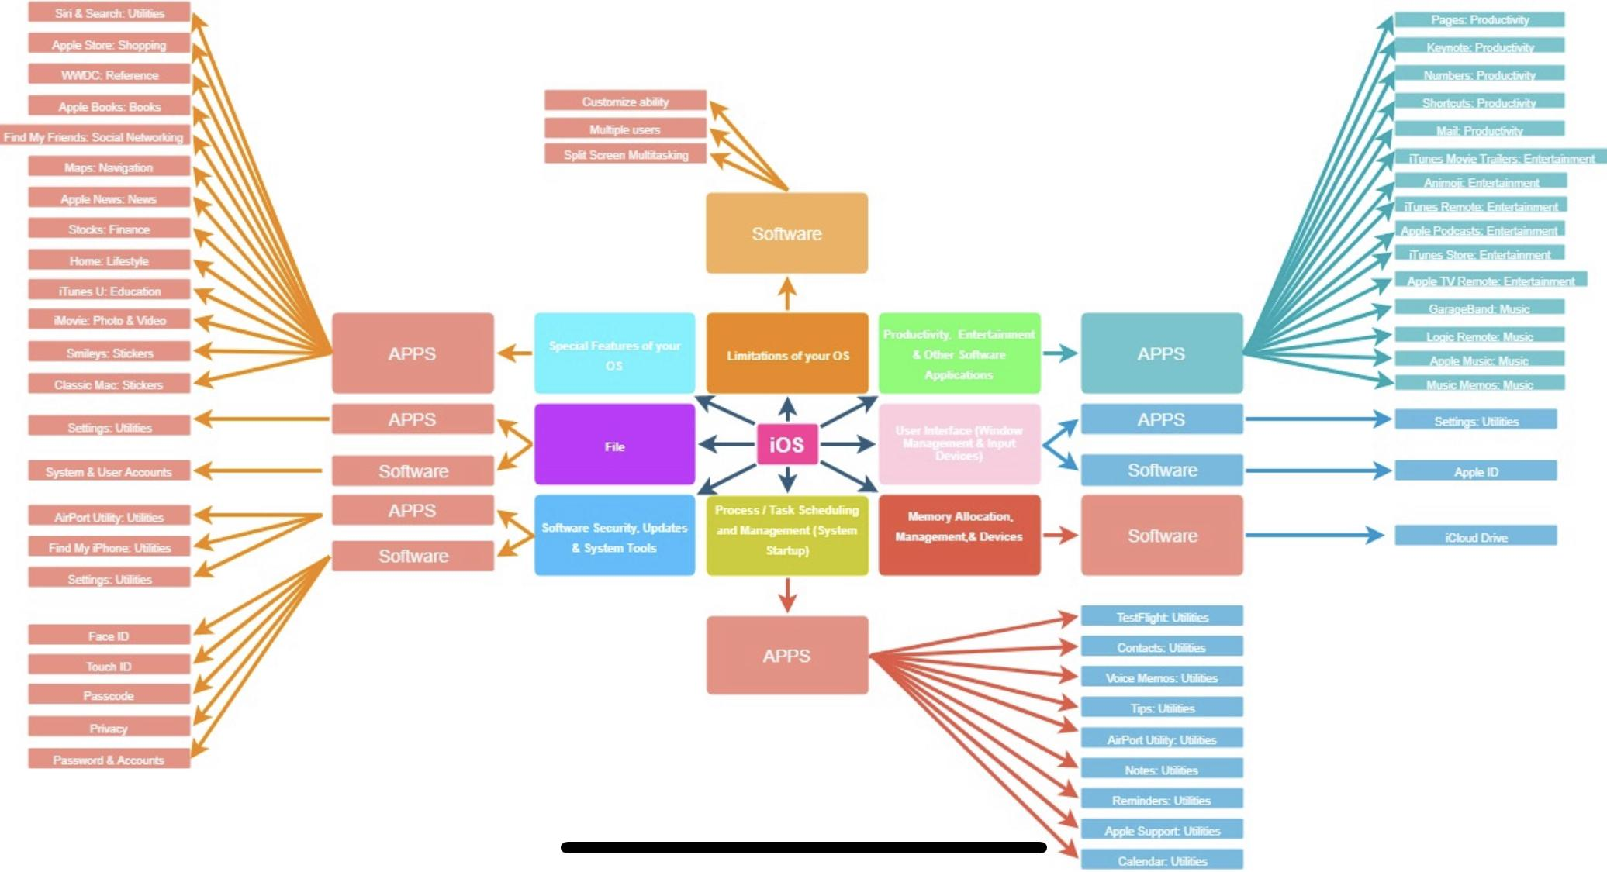

Citations

[https://en.wikipedia.org](https://en.wikipedia.org/wiki/IOS)

<https://www.apple.com/ca/>